



Taylor Borough Council, Mayor and Staff would like to wish all residents, friends, and family a very happy holiday season

Pond Street Storm Water Project PHASE 2 has started
This project is a storm drainage improvement project located along South Pond Street and North Pond Street in Taylor Borough. The site is located so that up slope developed portions of the Borough drain towards South Pond Street where the existing storm inlets and pipes are inadequate to collect the runoff. In addition, the existing storm inlets connect to the existing combined sanitary/storm system along South Pond Street. This combined sanitary/storm flow is conveyed along South Pond Street to North Pond Street and then to Church Street to an overflow chamber at its connection into the Lower Lackawanna Valley Sanitary Authority’s (LLVSA) interceptor line. In times of moderate rainfall, the overflow discharges into Keyser Creek east of North Main Street.
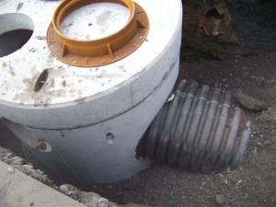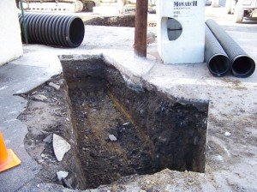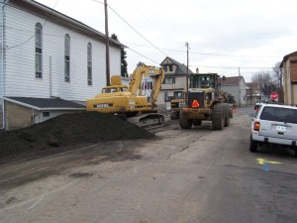

Pond Street Storm Water Project PHASE 2 has started The intent of the project is to provide an adequate separated storm collection/conveyance system along South Pond Street that will connect to the recently completed separated storm system on North Pond Street and Church Street (Phase 1 Project Area), eventually discharging to the Borough-Owned Colliery Property where additional controls such as rock-lined channels, storm water management/ponding basin and stabilized outlet channel to Keyser Creek have been completed through the efforts of both the PA DEP Bureau of Abandoned Mine Reclamation (BAMR) and Taylor Borough (via the PA DEP Growing Greener Grant Program). In addition, the subject project will provide a new separate storm collection/conveyance system that can be further expanded in the future to alleviate hydraulic overloads of the Borough’s existing combination sanitary/storm system and related storm flooding problems along the roadways upslope within the extent of the system’s drainage area. During the anticipated Phase 2B portion of the project, the separate storm system will be expanded along South Pond Street to West Grove Street and to the South Ridge Street Intersection. Phase 2B may be ready for construction during 2012.
The Phase 2A project includes the installation of 6 six-foot diameter concrete storm manholes, 140’ of 15”, 35’ of 24”, 30’ of 30” and 330’ of 36” diameter High Density Polyethylene (HDPE) storm pipe, 10 new storm inlets, and associated pave, walk, curb and treelawn restoration work within the limits of the Phase 2A project. The new storm system will follow the general route of the existing combination system pipe along South Pond Street and North Pond Street and will connect to the recently completed separated storm system on North Pond Street.
Some of the existing inlets, which are small and in poor condition, will be replaced with PA DOT standard inlets with bicycle-safe grates, and additional inlets will be installed where necessary to help collect the storm drainage more efficiently. All inlets will connect to the new storm pipe either at manhole locations or at the new main line through the use of “TEE” connections. The connecting pipes from inlets to the main line will be 15” HDPE.
Once the Phase 2A and subsequently Phase 2B are completed, the contributing drainage area will discharge through the new separated storm pipe system to the completed system on North Pond and Church Streets to the storm basin within the Colliery Property. The final product will be a completely separated storm drainage collection and conveyance system for this portion of Taylor Borough, alleviating basement and roadway flooding, and greatly reducing the combined sewer overflows present at the LLVSA diversion chamber.
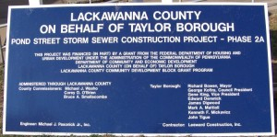

Taylor Borough Council Recognized Taylor Jr Vikes A Team Football Players and Cheerleaders

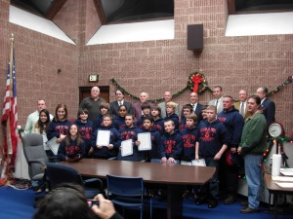
Taylor Borough Council has recognized the Taylor Jr Vikes A team football players and cheerleaders for an outstanding 2011 season. The Council , together with the Mayor, proclaimed Wednesday, December 14, 2011, as
“TAYLOR JUNIOR VIKES A TEAM DAY”
PROCLAMATION
WHEREAS, the Taylor Junior Vikes A Team has always been a source of pride to our community and has maintained an outstanding commitment to excellence; and
WHEREAS, the enthusiasm and commitment of the team and cheerleading squad serves as an inspiration; and
WHEREAS, the Taylor Junior Vikes A Team, together with the Cheerleading Squad, their respective support and coaching staff (collectively referred to as Team) exemplify the community’s goals and values; and
WHEREAS, the Team claimed ALL COUNTY CONFERENCE JR. Football League, 2011 American Division Champs and Super bowl XII Runner-up; and
NOW, THEREFORE, the Council of the Borough of Taylor, together with the Mayor, do hereby proclaim Wednesday, December 14, 2011, as
“TAYLOR JUNIOR VIKES A TEAM DAY”
in the Borough of Taylor, and ask our Citizens to join us in congratulating and recognizing the Team for its distinguished accomplishments.
DULY PROCLAIMED AND ADOPTED, this 14th day of December, 2011, by the Council of the Borough of Taylor, Lackawanna County, Pennsylvania in lawful session duly assembled.

Taylor Borough Council Approves $3M Budget
TAYLOR - Borough council unanimously adopted a $3 million budget for 2012 that is largely funded with payments from Alliance Sanitary Landfill Inc. and revenue from borough savings accounts.
The $3,140,145 budget is composed of a $2,878,645 operating budget and a $261,500 capital budget.
The spending plan will draw $371,488 from the landfill's payment to the borough. Another $20,000 of landfill payments will be devoted to the development of Taylor Colliery and the borough's two fire companies, Taylor Fire & Rescue and the Taylor Fire Department.
Due to the landfill payments, Taylor does not have a municipal tax. To balance the budget, nearly $1 million from borough savings accounts will be tapped as revenue.
The 2012 budget represents a decrease from this year's $3.24 million budget, the difference being $100,000 in grant money the borough received this year but won't get next year, said Borough Manager Dan Zeleniak.
The council also approved a four-year contract with the borough's seven DPW workers that will give them a 3-percent raise each

Work Continues on Gateway Project
PennDOT continues working on the Gateway project on Main and Union Streeet, in the Borough. PennDot is currently landscaping the area at the entrance of the bridge and the area of the former Sam's Deil. The landscaping portion of the project has PennDot planting trees and shrubs. Along with planting they are also placing Mulch around the area
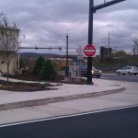

Do you have the TIME?
Do you have the Time? You won't have to ask that question any longer if you are walking or driving down Main St or Union St. PennDOT continues working on the Gateway project on Main and Union Street, in the Borough. PennDot yesterday put a few of the finishing touches on the project. Few of the finishing touches added are the benches and trash containers. One of the main attractions to the project has been the lights on the bridge. But that has changed when PennDot installed the clock at the corner of Davis St and Main. The clock is black in color with gold trim. The header of the clock reads Borough of Taylor. The Gateway project is to welcome our residents home or visitors into our borough and now let them know what time they arrived.


By-Pass Road on Main Street OPEN
PennDOT removed the barricade from the by-pass road and closed the North Main Street bridge. Beginning on Wednesday October 12 at 12:30, the detour on Main Street will divert southbound traffic onto Oak Street, to the temporary by-pass road and back to Main Street. Northbound traffic will follow the reverse route of the detour.
A 10-ton weight limit will also be established on Union Street, according to PennDOT


Let There be LIGHTS

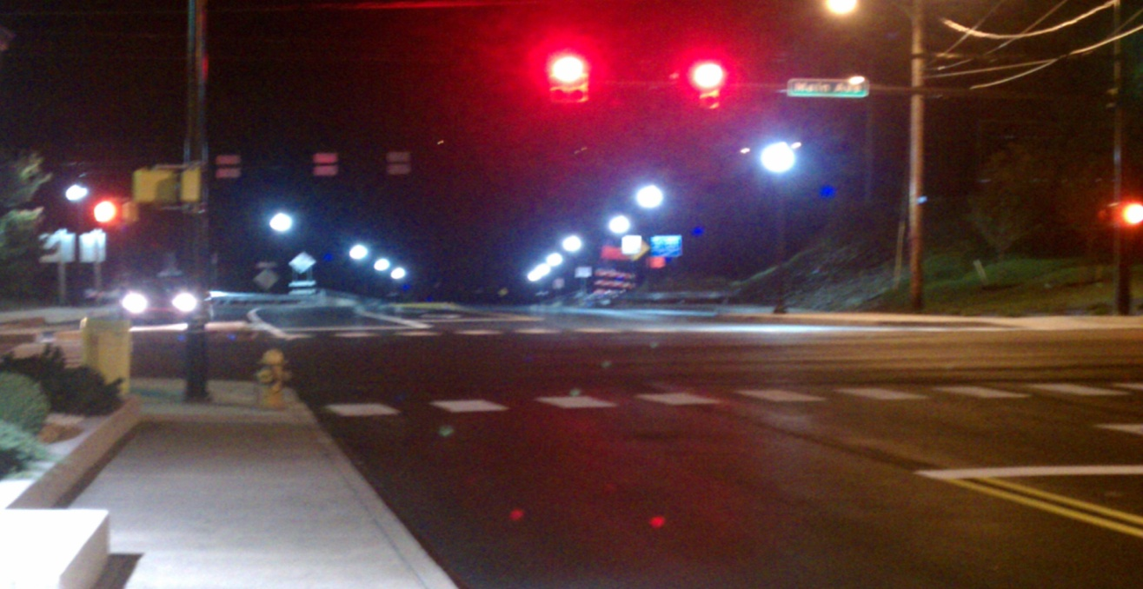
If you have not driven yet at night across the Veterans Memorial Bridge lately, then you didn't get to see the new lights shining bright at night. The bridge lights and road constructions on Main, Union and the bridge is part of Taylor Boroughs Grant for our Gate Way Project. The project grant proposal was written and overseen by John and Peg Derenick. With the help from Borough Manger Dan Zeleniak and Penndot the project has been moving forward with great success. The project is to welcome our residents home or visitors into our borough

Taylor Borough Recognized Dave Siminski for Helping Greenview West Neighborhood
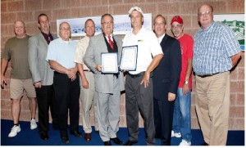
Taylor Borough Council has recognized Dave Siminski for spending a rainy August weekend keeping his neighbors’ homes from being flooded by a malfunctioning sewage collection system.
“Taylor Borough is blessed with volunteers who seek to alleviate the burden of their neighbors and Dave Siminski, in the spirit of volunteerism, assisted residents of the borough by helping pump out the sewer system and preventing what could have been a catastrophe,” said Mayor Richard Bowen when he presented Mr. Siminski with a proclamation. Mr. Siminski accepted the proclamation from Mayor Bowen and Taylor Borough Council during council’s September meeting.
Joe Icovazzi, Taylor’s public works foreman, said two pumps that move sewage out of a reservoir near Oak Street and Rinaldi Drive in Greenview broke down on Aug. 6, setting off alarms and causing a combination of sewage and stormwater to fill the reservoir and begin backing up toward nearby homes.“The rain wasn’t stopping and if we hadn’t been able to begin pumping out the reservoir the sewer system would have begun flooding into nearby homes,” Mr. Iacovazzi said.

PROCLAMATION
WHEREAS, David Siminski is a lifelong Taylor resident and is employed by Waste Management/Alliance Landfill; and
WHEREAS, the Taylor Community is blessed with volunteers who seek to alleviate the burden of their neighbors; and
WHEREAS, David Siminski in the spirit of volunteerism assisted residents of the Borough of Taylor during times of need by offering his assistance and employing the use of Alliance vacuum truck from time to time.
NOW, THEREFORE BE IT RESOLVED that the Taylor Community honors David Siminski for his service for our community.
DULY PROCLAIMED AND ADOPTED, this 14th day of September, 2011, by the Council of
the Borough of Taylor, Lackawanna County, Pennsylvania in lawful session duly assembled

BOROUGH OF TAYLOR, PENNSYLVANIA

REFUSE & RECYCLING
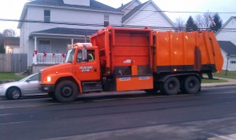
Residents are reminded to set your Containers curbside by 7:00 a.m. on the designated day
Any refuse for collection shall be set out no earlier than 6:00 p.m. of the day preceding the refuse pickup . All recyclables, including newspapers, magazines, glass, plastic, aluminum and tin cans will be collected. Newspapers and magazines must be separated, bundled and placed on top of your recycling containers.

Its winter time and the snow will be fast approaching
Its winter time and the snow will be fast approaching Taylor Borough. Taylor Borough Council would like to remind all Taylor residents that, the placement of any objects intended to save or protect parking spaces in front of properties is illegal. This is a citable offense for the residents who placed the object in the streets. Objects placed in the Borough Right-of Ways will be removed and disposed of accordingly. Along with the resident being cited
While making our streets clean and safe our Department of Public Works has been having problems with homeowners who have portable basketball hoops that hang out beyond the curb lines. The Department has had a few incidents over the years when the plow trucks catch on the rim or the net of the basketball hoops. Taylor Borough Council is asking all residents to move the basketball hoops away from the roadway so this can be avoided and make it safer for our Department of Public Works employees in removing the snow

